**Guide for Students Majoring in Network and New Media**

Manuscript published on *South China Morning Post*

BI Wenhui

GU Yinsong

WANG Shuo

ZHAO Wenqi

Hong Kong Baptist University

Since the 20th century, communication activities have undergone fundamental changes, from newspapers and magazines in the past, to radio and television, and then to the new network media today. It is the combination of network technology and digital media, the combination of "arts" and "science".

Employment is the last choice of students' career and the first choice to enter a new stage of society. 2021 graduation season is approaching, we have made a career guide for students majoring in network and new media, to guide you to see what jobs are in demand in new media positions, and whether the skills students learned in school is enough? What else can be done to make up for it? Know yourself and your enemy, you can never lose a battle.

**Comparison of the talent training program and job requirements**

We analyzed the talent training programs of 20 colleges and universities for network and new media majors. Because the talent training program is the teaching information of the school, different schools have different levels of information disclosure, and many schools have not disclosed their own training programs (or have not disclosed them on the Internet), so we only choose all the schools that have disclosed their own training programs on the Internet (School Official Website and third-party education institutions). The level of schools in this is inconsistent, including top schools and specialized colleges, covering a wide range of areas, which can be understood as the object of universal research.

We firstly obtained the top ten high-frequency words in the training objectives: *Network, communication, media, editorial, production, information, management, operation, analysis, and promotion.*

The training objectives of the institution are "online" in character, but retain a strong traditional discipline.

Then we analyzed the word frequency of job requirements in two job sites for internships and regular jobs.

First, the top 20 high-frequency words of job requirements in "internship monk" are *operation, media, content, video, platform, experience, planning, communication, activity, team, assistance, product, user, project, copywriting, design writing, data, software, public.*

Among the hard competency requirements are operation, planning, video, design, copywriting, writing, data, software; soft requirements are experience, communication, assistance. The main requirements in the internship positions are media-related skills, which can be covered by media courses or knowledge basics such as film and television production, editorial, and public relations. However, the data and software that appear do not belong to the general category of media and deserve attention. The science-based skills requirements that appear: data analysis, development.

Next are the top 20 high-frequency words in the job requirements of "Wisdom Recruitment": *operation, media, planning, responsible, content, promotion, platform, activity, experience, copywriting, WeChat, video, user, brand, marketing, public fans, writing, analysis, product.*

Among the hard skills required are operation, planning, promotion, copywriting, video, marketing, writing, and analysis; the soft skills required are responsible and experience. Compared with internship positions, it is largely the same, but with the addition of media-related business skills: marketing, promotion and analysis, indicating that these three competencies are in greater demand in formal positions. Operations, planning and copywriting are ultra-high frequency words that appear on both sides of the spectrum, and the courses behind them, such as advertising, PR and editorial, should be highly valued. The science class skill requirement that emerged: data analysis.

After comparing talent training and job requirements, it can be found that the majority of skills can be matched, indicating that the talent training program is scientific and also in line with the current trend, which is proof of good interoperability between schools and enterprises. However, data analysis or data did not become a high-frequency word, indicating that the cultivation of data thinking and data analysis ability is not enough attention. Only half of the schools have arranged media data analysis courses in the talent training programs collected, but almost no schools have set up basic courses related to data, such as statistics and mathematics.

**Regional distribution of the number of positions**

The top five cities in terms of the number of internship positions: Beijing, Shanghai, Guangzhou, Chengdu, Shenzhen. The top five cities in the number of formal positions: Guangzhou, Shanghai, Shenzhen, Wuhan, Chengdu.

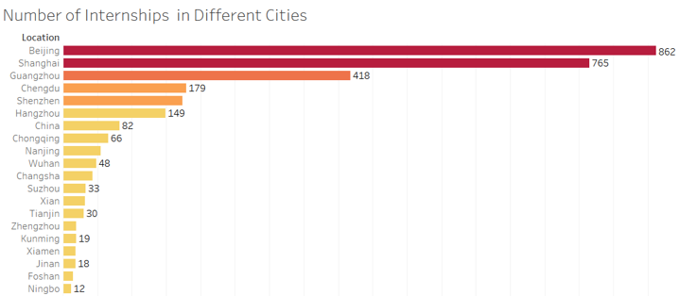

*Figure 2:* Number of internships in different cities (top 20)

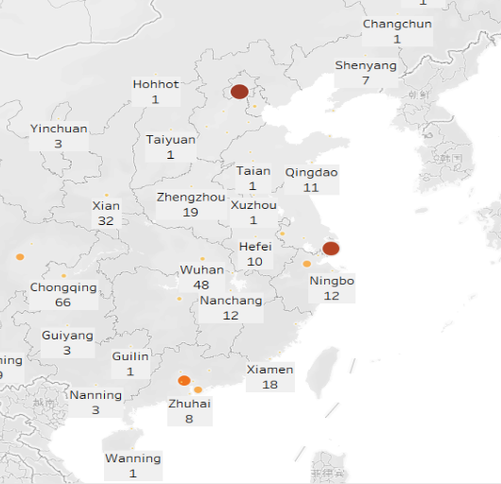

*Figure 3:* The distribution of internships in different cities

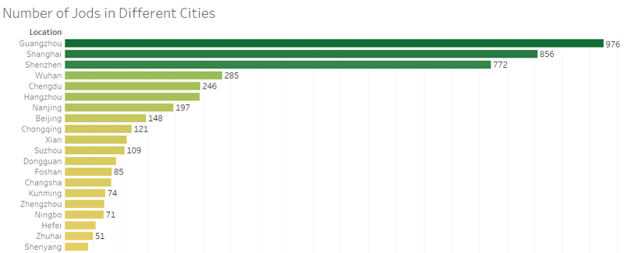

*Figure 4:* Number of jobs in different cities (top 20)

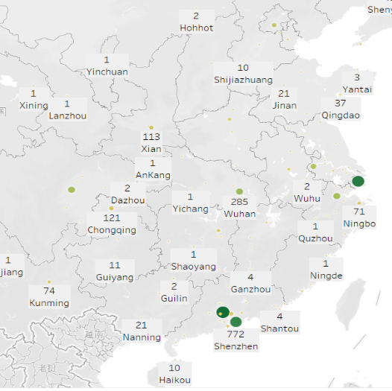

*Figure 5:* The distribution of jobs in different cities

By comparison, the four cities of Shanghai, Guangzhou, Shenzhen and Chengdu are in great demand regardless of internship positions or formal positions. The demand for internship positions in Beijing is the first, but the number of formal positions is only ranked eighth, indicating that it is relatively difficult to convert internships. And internship positions ranked tenth in Wuhan, the number of formal positions ranked fourth, it can be seen that the industry is still a large job vacancy.

**Top5 cities education requirements and job requirements**

Basically, more than half of the internship positions in all cities require a bachelor's degree, while Chengdu has lower education requirements and a relatively large proportion of college or unlimited. It is worth noting that Beijing and Shanghai have a small number of internship positions that require a master's degree, indicating the need for highly skilled personnel, and also reflecting the greater competition in the industry in these two cities.

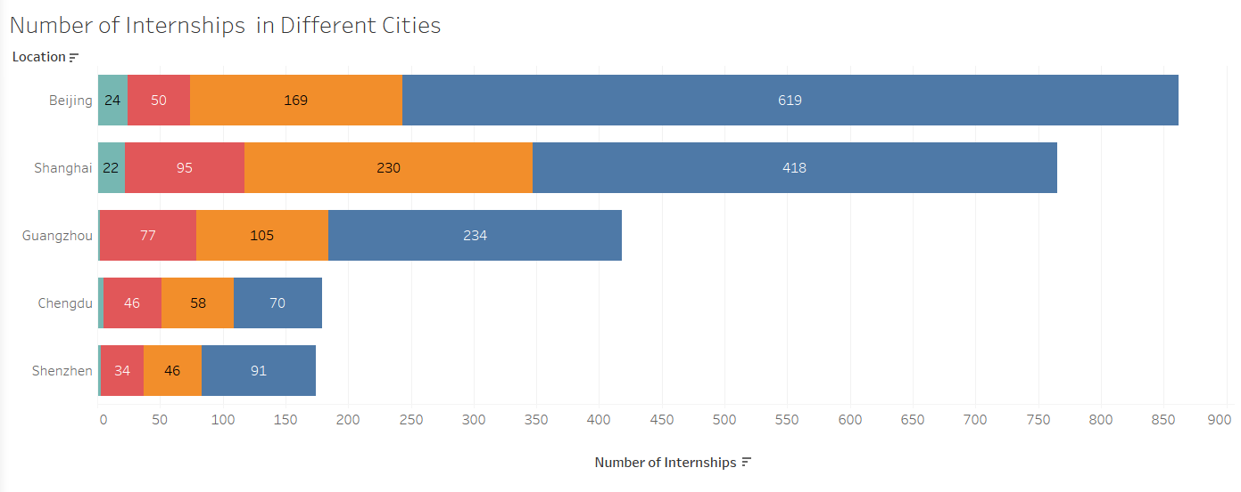

*Figure 6:*Number of different education requirements for internships in the top five cities (blue - undergraduate, red - college, green - master, orange - unlimited)

The top three high-frequency words in Beijing, Chengdu, Shanghai, and Shenzhen are very uniform: operations, content, and media. Reflecting the requirements of the internship position. And Guangzhou is video, media, operations. It shows that Guangzhou has a better development of Internet video.

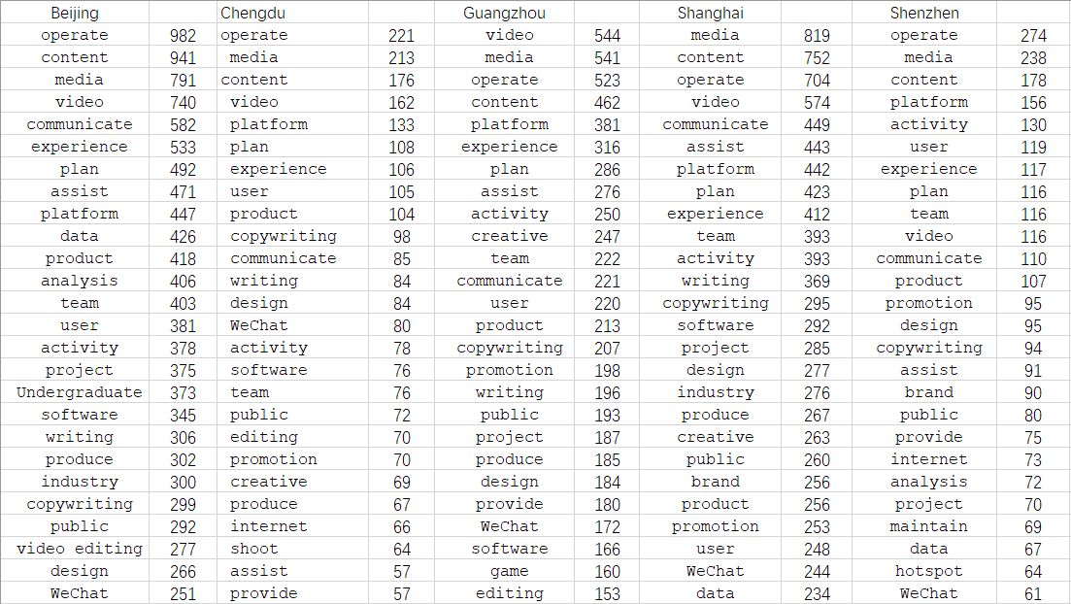

*Figure 7:*The 25 most frequently mentioned words in the internship requirements of the top 5 cities

For formal positions, the top five cities are more uniform in terms of educational requirements. The most turned out to be college, accounting for about two-thirds of the total. And bachelor's degree accounted for one-third. The reduced educational requirements compared to internship positions indicate that there are still many bottom-level positions open in this industry.

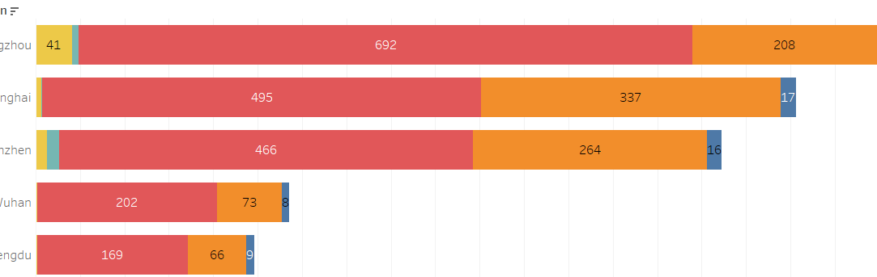

*Figure 8:*Number of different education requirements for jobs in the top five cities (yellow - secondary school, green - high school, red - college, orange - undergraduate, blue - null)

The top three high-frequency words in Guangzhou, Shenzhen, Wuhan, and Chengdu are operations, media, and planning. In contrast to the internship, formal positions need to have the ability to plan talent, not just a single content output. And Shanghai still needs a lot of talent in content.

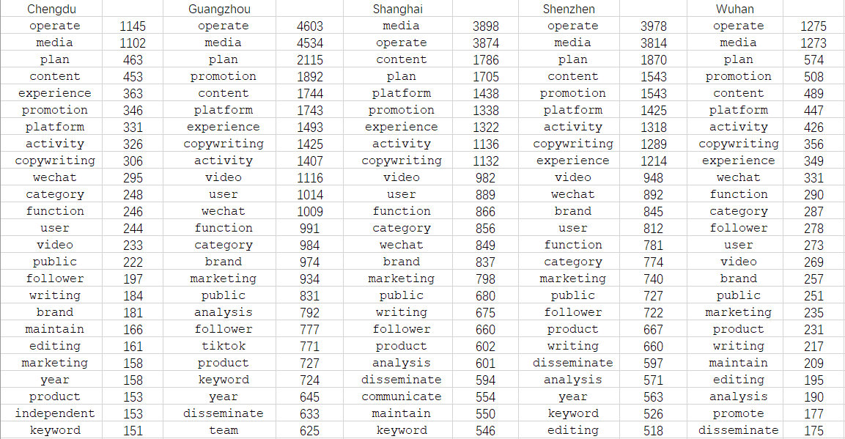

*Figure 9:*The 25 most frequently mentioned words in the job requirements of the top 5 cities

**Market Analysis**

The vast majority of enterprise types are private companies, we usually call the "iron rice bowl" of state-owned enterprises and institutions accounted for less. There are only a small number of large listed companies. In general, the types are mainly small businesses. Freshers need to be careful when looking for jobs to compare.

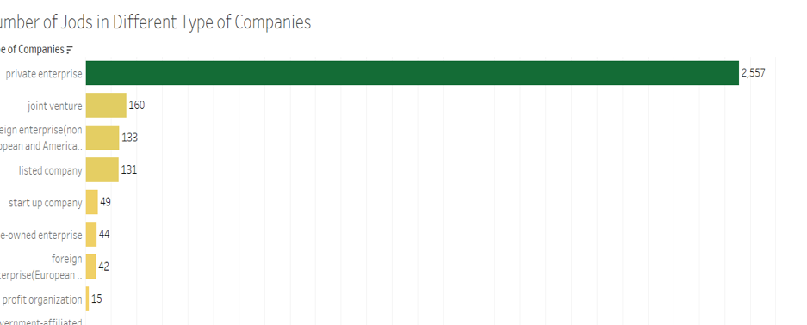

*Figure 10:* Number of jobs in different type of companies

In terms of industry distribution, it is interesting to note that the top ranking is the education industry, with Internet and e-commerce coming in second. It can be seen that education is also transforming, and traditional education is developing into online education. Especially since the outbreak, the development of online education is very considerable. The next ranking is the tertiary industry such as FMCG, apparel, medical and film.

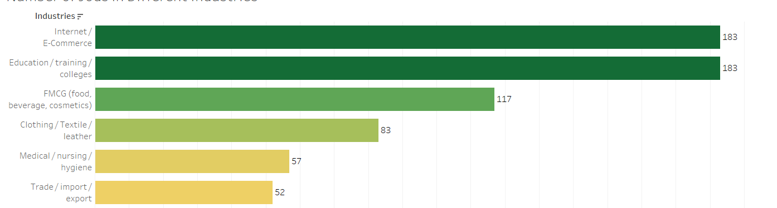

*Figure 11:* Number of jobs in different industries

Another point of concern for graduates seeking employment is the salary level. In terms of internship salary, the top cities are basically located in the Yangtze River Delta and the Pearl River Delta region. This includes some second and third-tier cities, which can also be considered for students who have just graduated. In terms of formal positions, the top three cities are Beijing, Shanghai and Shenzhen. Relatively, the living expenses in these cities are also larger.

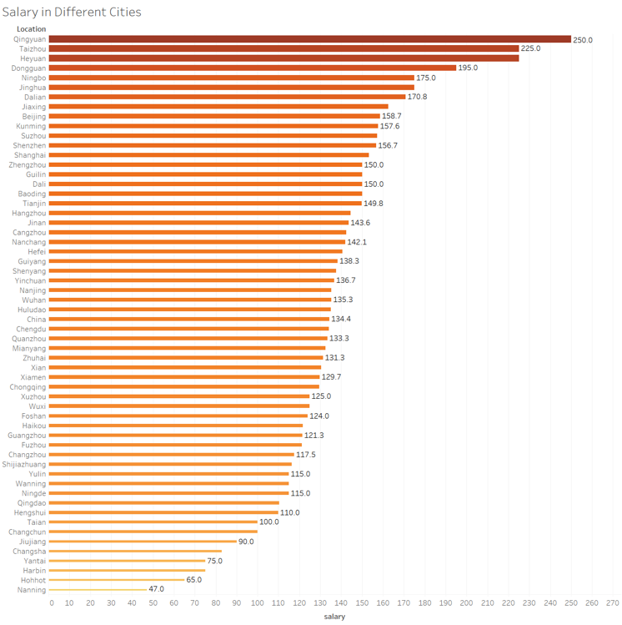

**Summary and Suggestions**

In general, web and new media is a major with many employment options and broad development prospects. Especially in the first and second-tier cities, there are more opportunities for the development of this major. Students don't need to choose "Beijing, Shanghai, Guangzhou", they can find suitable jobs near their hometown. Students with lower education don't have to worry about finding a job.

Nowadays, all major companies have started to adopt the mode of combining online and offline operation, and we can see that various industries gradually integrate the network and physical industry with each other. Therefore, the employment direction of the emerging profession of network and new media can be very wide. For example, not only self-media operation companies and advertising companies, but also the brand marketing departments of some traditional enterprises are in need of such talents. There is also a large number of e-commerce companies also need to do online marketing and promotion of talent. And not to mention the Internet companies, but also need a large number of new media operations practitioners. And about the positions that can be engaged in, is also very rich, like copy editors, advertising designers, brand PR, journalists, editorial planning and so on. The education industry is also a good employment choice. Even government departments and institutions also need talents in this field.

Of course, to have a broader development platform needs to rely on people to learn more professional knowledge, that is, to master the basic knowledge of communication, but also to master the network of new media information dissemination knowledge and practical skills, can use the network and new media for information writing, planning, good at the integration of a variety of media means for integrated communication, both new media organization and management capabilities. In addition, the cultivation of data analysis ability is also very important.